I worked alone

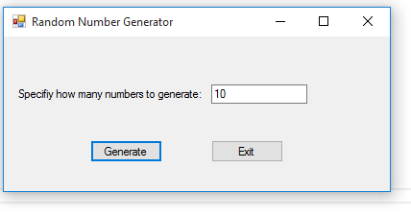

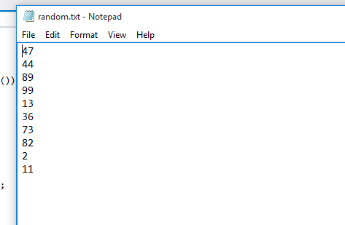

using System;

using System.Collections.Generic;

using System.ComponentModel;

using System.Data;

using System.Drawing;

using System.Linq;

using System.Text;

using System.Threading.Tasks;

using System.Windows.Forms;

using System.IO;

namespace RandomNumberGen

{

public partial class Form1 : Form

{

public Form1()

{

InitializeComponent();

}

private void generateButton_Click(object sender, EventArgs e)

{

try

{

int RandomNumberAmount;

RandomNumberAmount = int.Parse(inputTextBox.Text.ToString());

int random = 0;

int count =1;

saveFileDialog.DefaultExt ="txt";

StreamWriter outputFile;

if (saveFileDialog.ShowDialog() == DialogResult.OK)

{

outputFile = File.CreateText(saveFileDialog.FileName);

Random rand = new Random();

while(count <= RandomNumberAmount)

{

random = rand.Next(100) +1;

outputFile.WriteLine(random);

count ++;

}

outputFile.Close();

}

else

{

MessageBox.Show("Operation was cancelled");

}

}

catch

{

MessageBox.Show("Please enter a valid integer.");

}

}

private void exitButton_Click(object sender, EventArgs e)

{

this.Close();

}

}

}